Hardware Simulation

**Noise source**

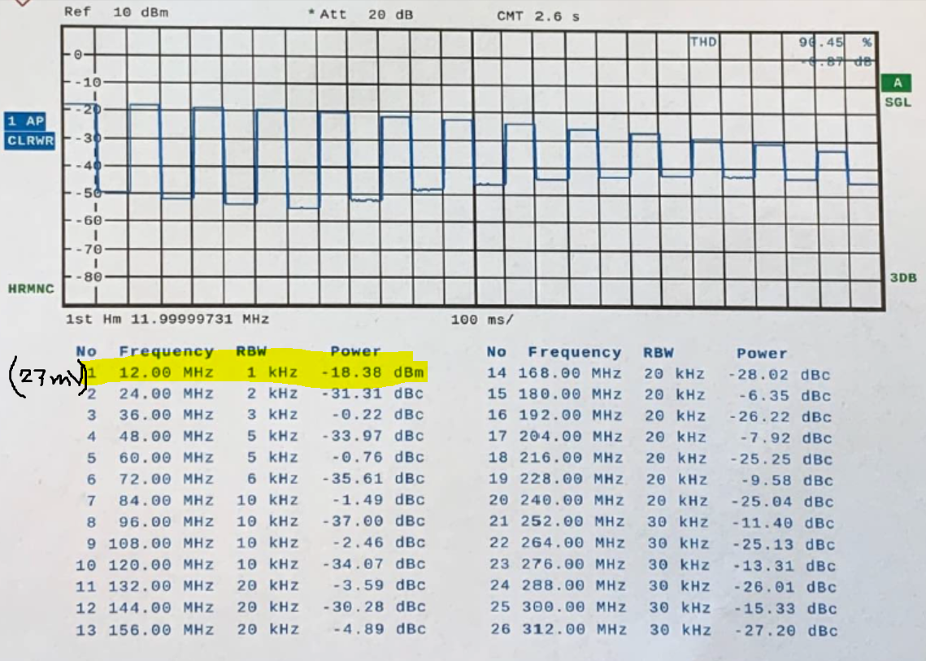

**Noise Source with filter (except capacitors)**

At 12 MHz, the output power is -48 dBm

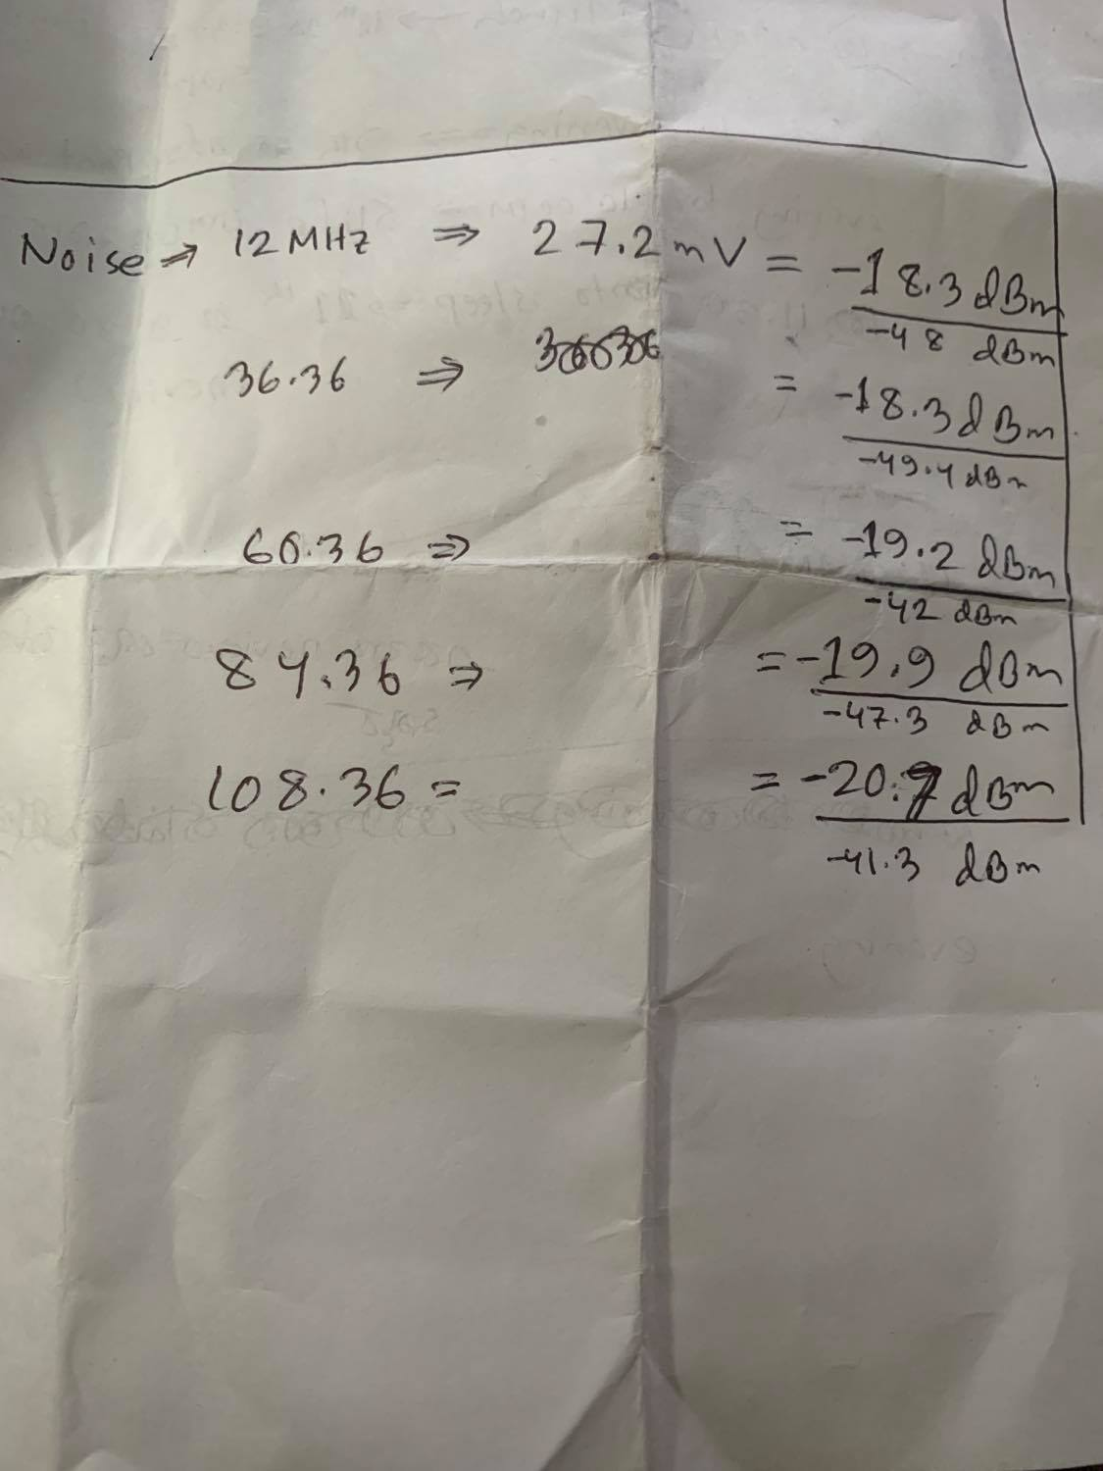

Software Simulation

**Noise source**

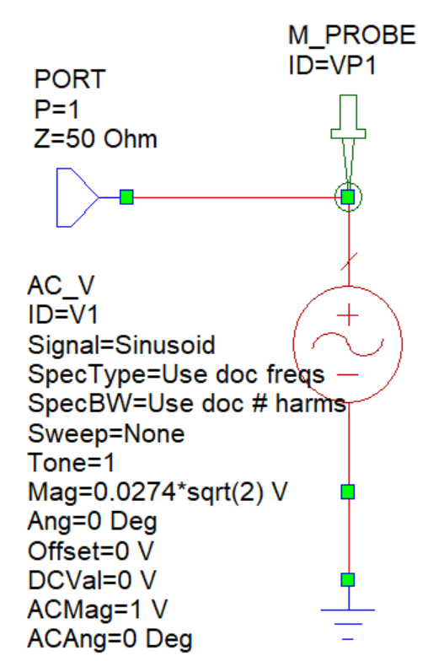 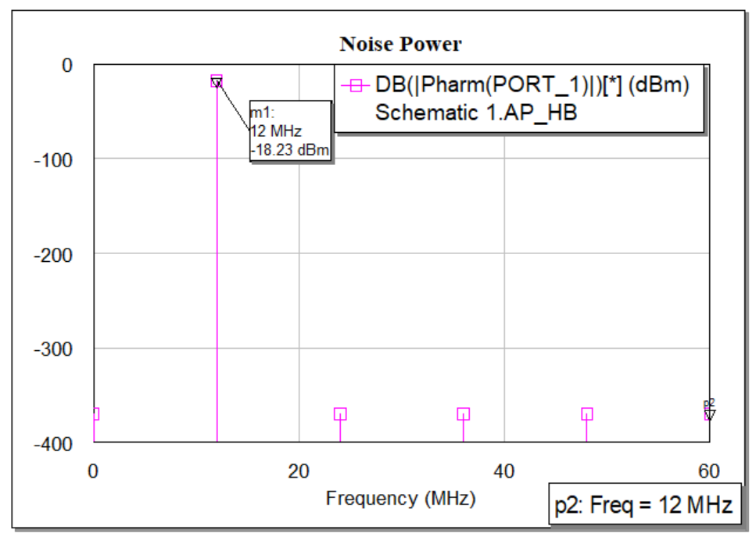

**Noise Source with filter (except capacitors)**

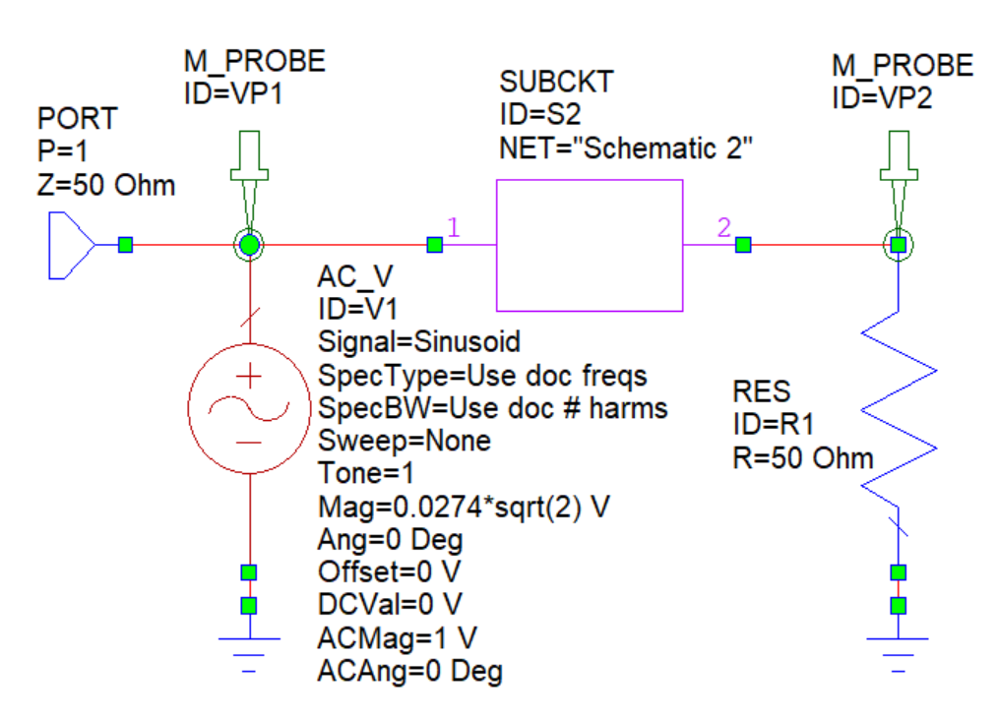 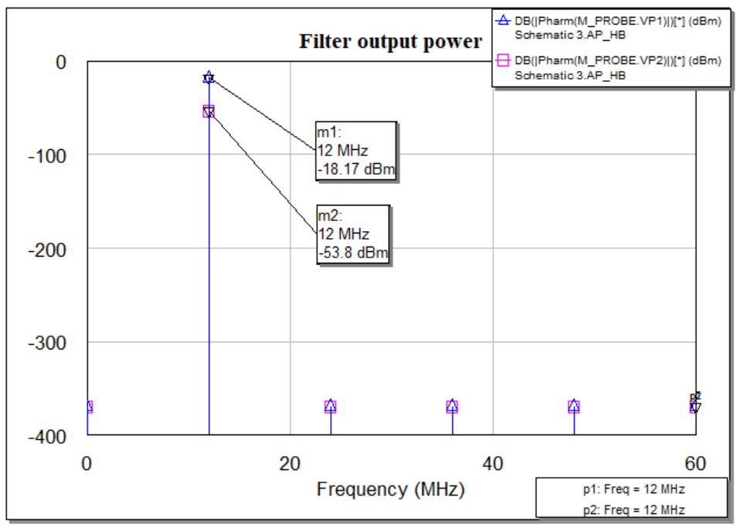

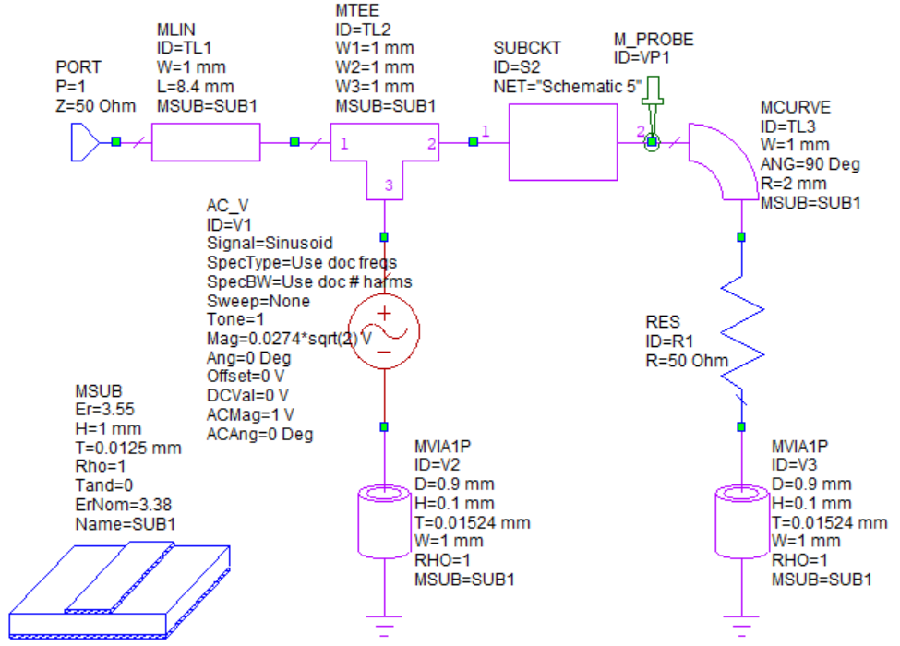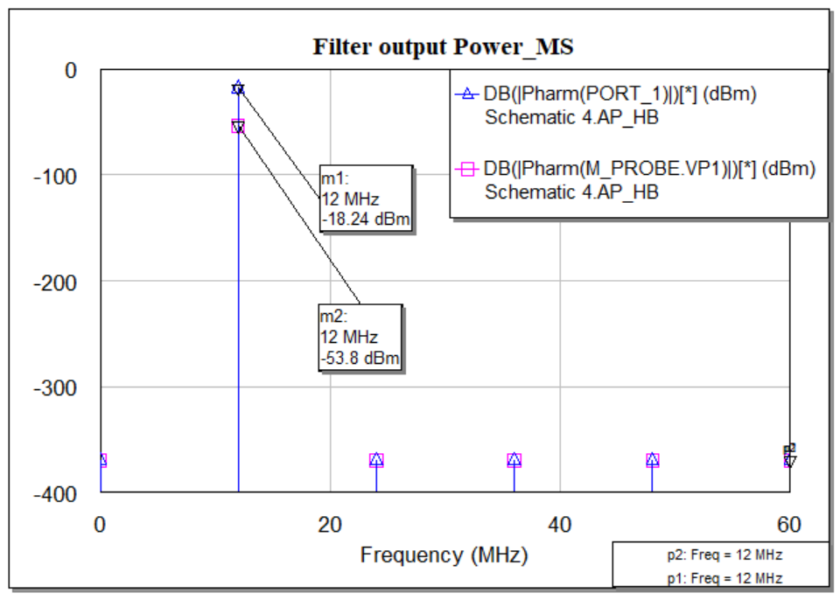

Facts:

* Noise source is producing -18.3 dBm harmonic power at 12 MHz. both is Hardware and software
* Filter attaching alone with noise source producing
  + -48dBm harmonic power at 12 MHz in Hardware
  + -53.8dBm harmonic power at 12 MHz in Software (both MS and OL)
* Including capacitors lowering the value of Harmonic power
* Explain why the harmonic power is such lower as 30dBm down.

|  |  |
| --- | --- |
| Frequency (MHz) | Power (dBm) |
| 12 | -48 |
| 36 | -49.4 |
| 60 | -47 |
| 84 | -47.3 |
| 108 | -41.3 |